**CANDIDATE INFORMATION FORM**

|  |  |
| --- | --- |
| **MANDATORY FIELDS** | |
| Name of the Candidate | DHANUSH I |
| Father's Name | INDRAKUMAR C |
| Date Of Birth | 08-06-2001 |
| Mobile No. | 7829066019 |
| Email ID | dhanushindrakumar123@gmail.com |
| PAN Card No | GMLPD3230A |
| Passport No | W9652398 |
| SSN No (If Applicable) |  |

|  |  |
| --- | --- |
| **RESIDENCE ADDRESS DETAILS** | |
| Permanent Address | #18/24 20TH B CROSS MISSION ROAD SAMPANGIRAMANAGAR BANGALORE-560027.  Town/City: BANGALORE Pincode:560027  Landmark: HCG HOSPITAL Phone:7829066019 |
| Type of residence | Own House :Yes |
| Duration of Stay | From (Month&Year): 02/2022 To(Month&Year):Current |
| Residence Contact Number | 7829066019 |
| Current Address | #18/24 20TH B CROSS MISSION ROAD SAMPANGIRAMANAGAR BANGALORE-560027.  Town/City: BANGALORE Pincode:560027  LandmarK: HCG HOSPITAL Phone:7829066019 |
| Type of residence | Own House: Yes ______________ |
| Duration of Stay | From (Month&Year): 02/2022 To(Month&Year): |
| Residence Contact Number | 7829066019 |

**MANDATORY:Attach copy of any of the following as address proof for EACH ADDRESS:**

Any Govt. recognised valid address proof such as Voters ID or Driving License or Aadhar Card or Gas Bill

|  |  |
| --- | --- |
| **EDUCATION INFORMATION** | |
| Course Name | B.Tech in CSE |
| Registration No | 19ETCS0020235 |
| Duration | From (Month&Year): 08/2019 To(Month&Year):08/2023 |
| Year of passing | 2023 |
| Specialization | Computer Science |
| Name &Address of the College/Institution | MS RAMAIAH UNIVERSITY OF APPLIED SCIENCES, PEENYA 4TH PHASE.  City:BANGALORE____________________________Pincode:560054________ |
| Name &Address of the University | MS RAMAIAH UNIVERSITY OF APPLIED SCIENCES, PEENYA 4TH PHASE  City: BANGALORE Pincode:560054 |

**MANDATORY: Attach Degree Certificate or Provisional Certificate + Consolidated Mark sheet or All Semesters’ Mark Sheets**

|  |  |
| --- | --- |
| **PREVIOUS EMPLOYMENT INFORMATION1** | |
| Company Name | HashedIn By Deloitte |
| Company Address | #36/5 Somasundarapalya,27th Main Road End, HSR Layout.  City: BANGALORE Pincode:560027  Landline Phone number:___________________________________  Website:________________________________________________ |
| Employee ID No. |  |
| Designation | GRADUATE ENGINEER TRAINEE |
| Department | IT |
| Period of Employment | Joining Date: Relieving Date: |
| Employment Status | INTERNSHIP COMPLETED |
| Monthly Salary (Net Earning) | 40,000 |
| Reason for Resignation | COMPLETION OF INTERNSHIP |
| Reporting Manager Name |  |
| *Designation* |  |
| *Contact No.* |  |
| *Email ID* |  |
| HR Manager Name | SUJEETH |
| *Contact No* |  |
| *Email ID* |  |

**MANDATORY: Attach any one of the following with this form as employment proof:**

Attach Relieving letter, Experience or Service Certificate, Last 3 months’ payslip& Letter of Authorisation

|  |  |
| --- | --- |
| **Reference Verifications** (Leave this blank if not applicable) | |
| Reference Person Name |  |
| Contact Number |  |
| Email ID |  |
| Current Employer name |  |
| Current designation |  |
| Address of the Company |  |
| Nature of relationship | Colleague Friend Others |

**Please list down the document proofs attached with this form:**

1. AADHAR CARD
2. PROVISIONAL DEGREE CERTIFICATE.
3. EXPERIENCE CERTIFICATE

AADHAR CARD:

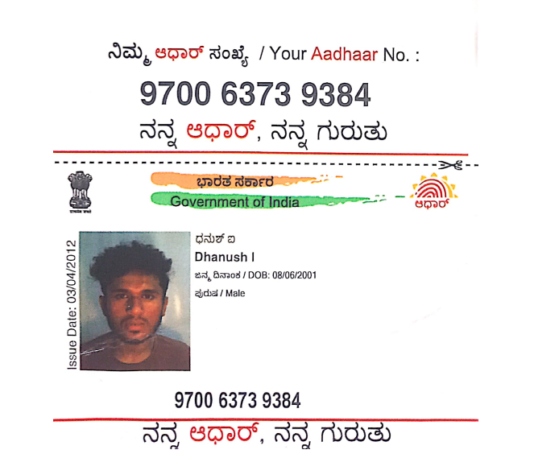

PROVISIONAL DEGREE CERTIFICATE:

